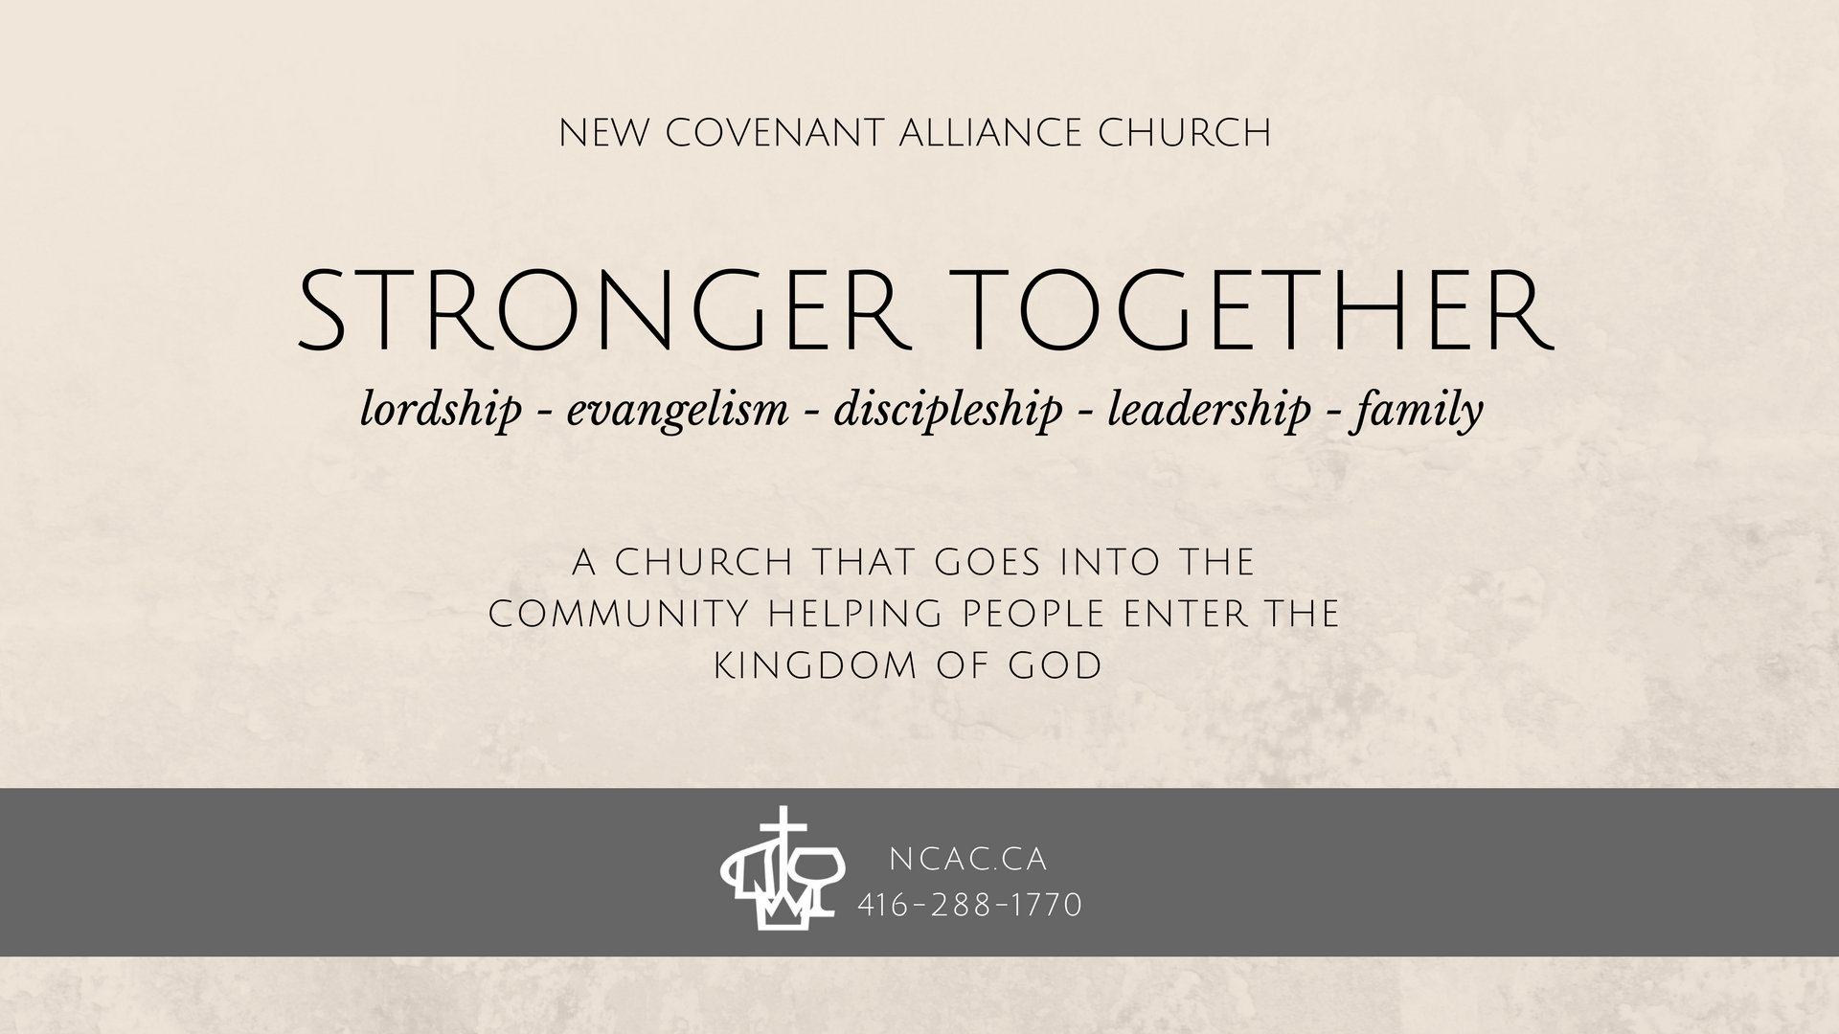
September 3, 2017
a few things to know

On Leave
Pastor Sit will be away for Norway STM from September 8 to18 and for vacation break with family from Sept 19 to Oct 6.
Shirley will be away for Norway STM from September 8 to 18 and vacation break from September 19 to 20.
Baptism and Membership Class
Baptism and membership class will begin in September. If you are interested in participating, or have questions about baptism and membership, please talk to either one of the EMT members or Pastor Vinson.
Marriage and Parenting Program
English Ministry will conduct a Marriage and Parenting program starting from every Sunday between Sept 17 and November 12 at 11:30 a.m.. It will be an 8-week program. The program will be conducted by Sarah and Ronald Wyse. They have been married for 30 years with 2 children. Ronald is a registered marriage and family therapist, and he is also the author of the book, "Beyond Survival: Marriage and the Quest for Paradise (2005). The program is good for married couples and couples about to be married. Please register with David Tong
Membership Meeting
Next membership meeting is re-scheduled for October 15.
An encouragement for you

Scripture Memory – James 1:5

If any of you lacks wisdom, you should ask God, who gives generously to all without finding fault, and it will be given to you.

Prayer Items

-To thank God for those who have previously served as EMT members, and for our current team.

-For discernment to lead the congregation in the right, God-inspired direction.

-For strength and wisdom to carry out the tasks required.

-For support and help from the church members.

-For energy and that God will guard EMT and the pastoral team against burning out.

Welcome to NCAC! We are so glad that you are able to join us today for our Sunday service. We believe that the Christian faith is about responding to God’s invitation to be in a relationship with Him – this relationship changes everything.

Fellowship, or building relationships with each other, is another important aspect of Christianity. And so, we would love to connect with you beyond our service time. There are a few ways to do that:

Fill out a welcome card
These are located in the pew in front of you. You can then place it in the offering bag that will be passed during service. There, you can leave us your contact information, comments, or questions. We will be sure to reach out to you!

Join a small group
A small group is more than just a social gathering. Rather, it is a community of people who are committed to Jesus and to being vulnerable with each other. It is for anyone who has a desire to grow in their faith, who wants to love and learn Scripture, and who wants to share their faith with others. If this sounds like something you are interested in, talk to the small group leaders. They would love to hear from you! Their contact information can be found in this bulletin.

Join us for food, coffee, and conversation
Food was an important part of community-building in the Bible. People gathered together, celebrated and feasted. Similarly, community is important to us and we invite you to join us in the fellowship hall after service. Please come and sit in on a small group as we eat, drink, and continue the conversation that today’s service started.
attendance & offering
69 | sunday service (english)
6/2 | bible & breakfast (kids/helps)
7/3 | children worship (kids/helpers)
$2,434.78 | last week’s total offering
today’s service
Catherine Chan | service leader
Brian Wong & Christine Tsang | greeter & usher
Catherine Chan | music leader
Samuel Leung & Matthew Leung | tech
Rev. Dr. Vinson Samuel | speaker
a few key people to connect with

marcus tong | downtown small group leader
keith lau & catherine chan | uptown small group leader
vincent yeung | mid-town small group leader

pastor amy wong | youth leader

pastor amy wong | children ministry pastor
pastor vinson samuel | english pastor
pastor simon sit | senior pastor

michael huynh | english elder
brian wong, david tong & ivan lee | english ministry leaders
God is Able
Acts 12:6-16
some things that stood out to me

some questions that i’m left asking
Sunday service

Call to Worship
SUNDAY SERVICE

Call to Worship
Praise & Worship
Welcome
Praise & Worship
Pastoral Prayer
Scripture Reading
Message
Song of Response & Offering
Holy Communion
Doxology & Benediction
Announcements
*Please leave space for latecomers by sitting forward and towards the middle aisle

*If you are a parent with a young baby, we welcome you to use the worship room to partake in service

